Project Report

1. INTRODUCTION
   1. Project overview:

In this project, we created CRM application for booking visa slots in the flights.

We created a application, they are

* Booking visa slots
* The booking visa slot app helps to book the visa slots in the flights.

1. Problem Definition and Design Thinking

2.1 Empathy map :

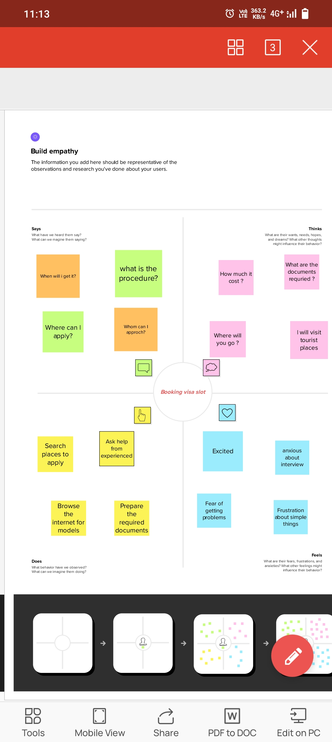

2.2 Ideation and Brainstorming map:  
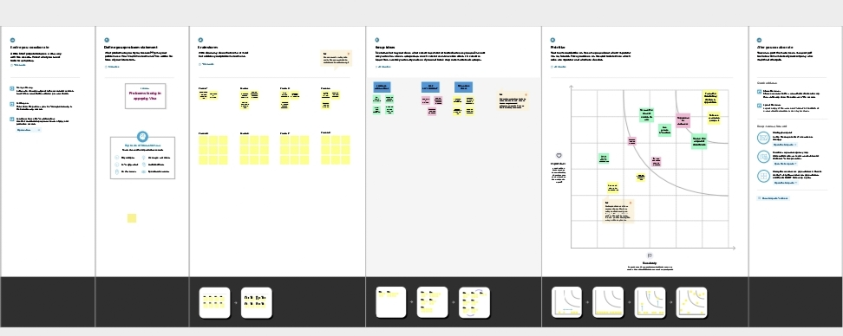.

1. Result

3.1Data Model:

|  |  |  |  |  |
| --- | --- | --- | --- | --- |
| Object | Passport | Visa slot | Payment | Reschedule/Cancel |
| Field | Full name | Location | Payment Mode | passportnumber(Master) |
| Field | Contact number | Passportnumber(Master) | Transaction id (Auto number) | Time |
| Field | Permanent  address | Visa slot  number | Cancel  Transaction | Cancel |
| Field |  |  | Visa slot number  (Master) | Status |

3.2Activity and screen shots

Milestone 1:

Creating developer account

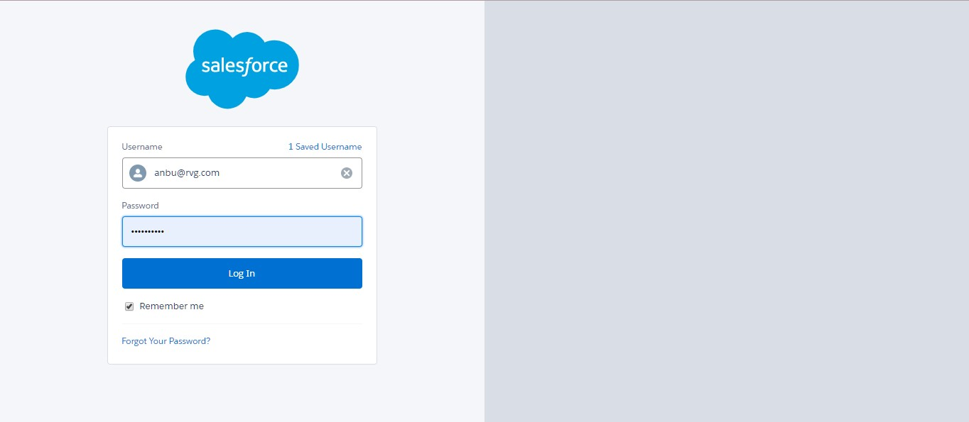

Milestone 2:

Activity 1- creation of object Passport,Visa slot, payment, reschedule.

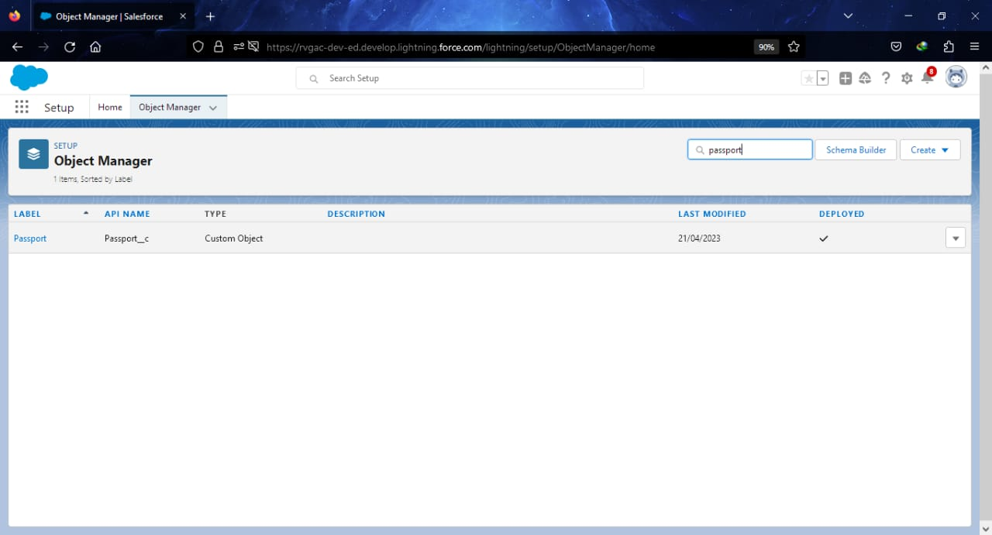

Activity 2-Creation of the fields forPassport,Visaslot,Payment,Reschedule/Cancel :

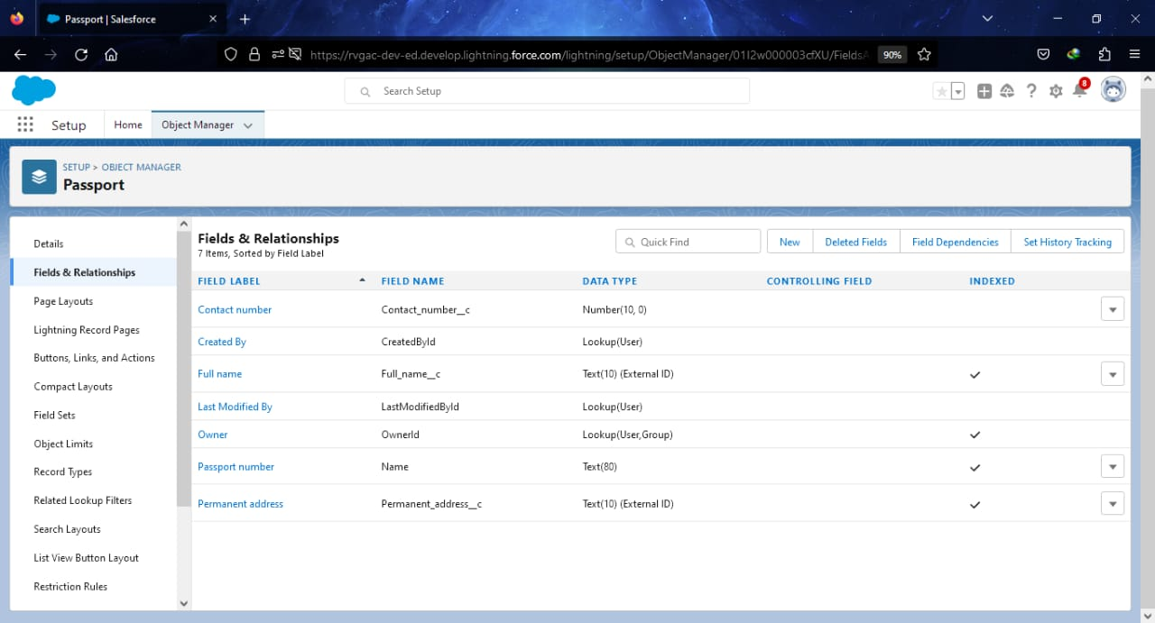

Milestone 3: Creation of the relationship between objects :

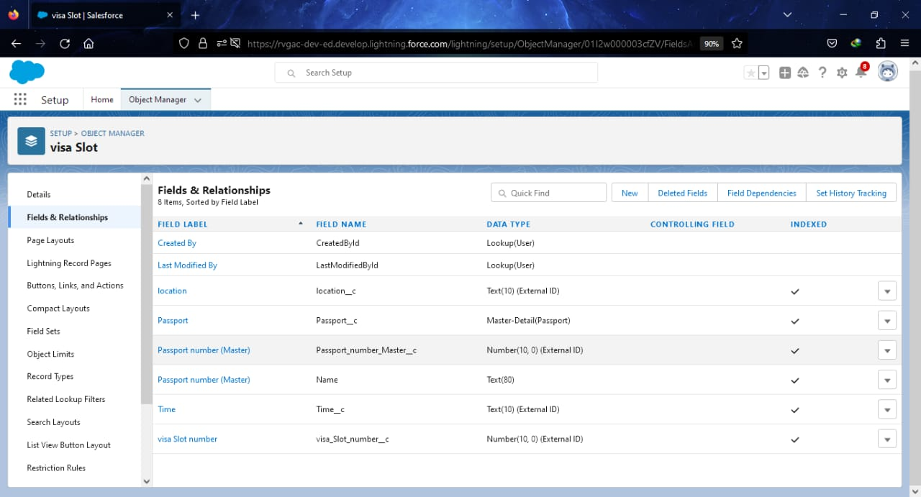

Milestone 4: Creation of app for visa slot in lightning :

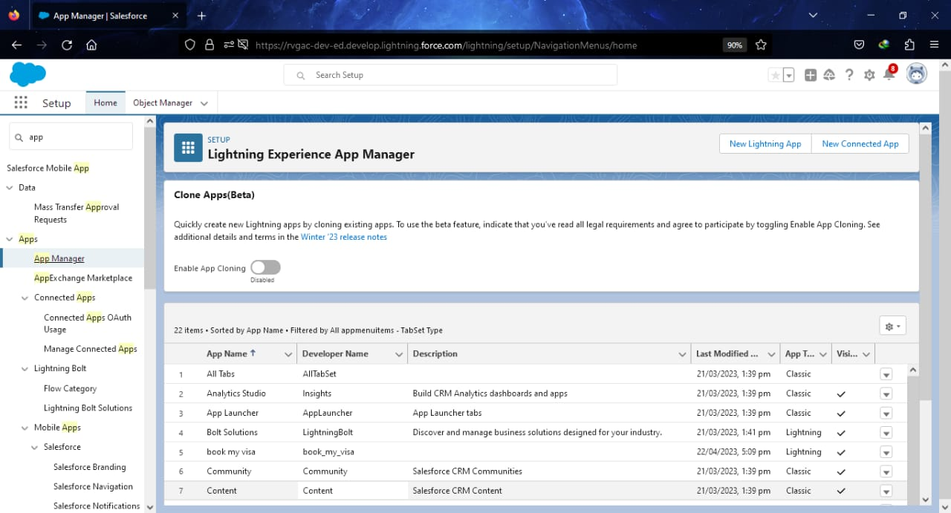

Milestone 5: Creation Of User :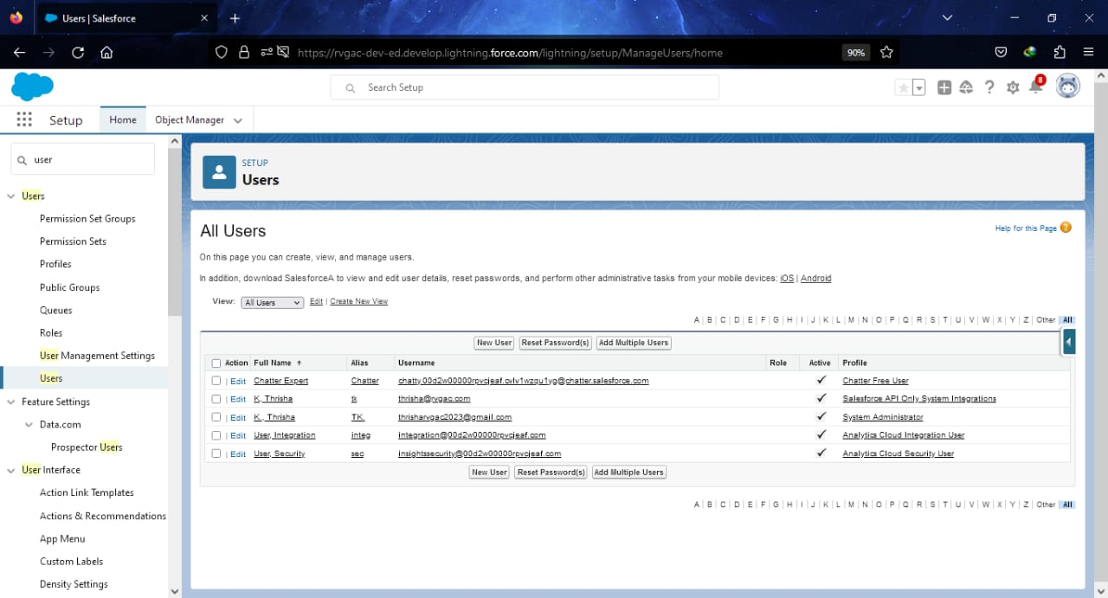

Milestone 6: Creation Of report:

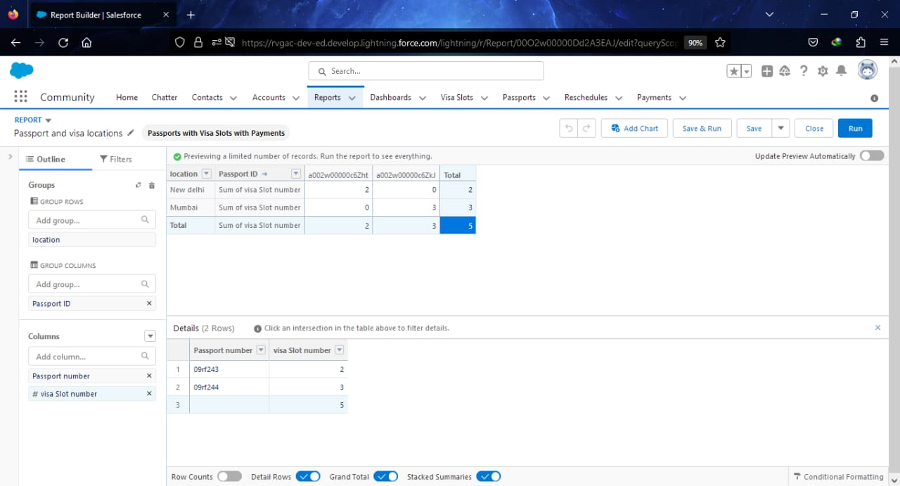

Milestone 7: Creation of Dashboard:

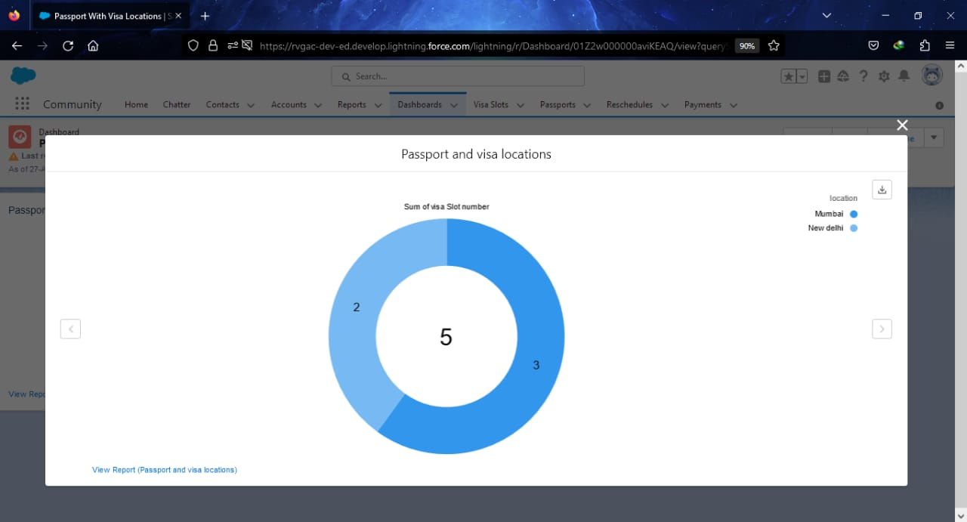

4. Trailhead Profile Public URL:

Team leader :https://trailblazer.me/id/akashv6

Team member 1:

Team member 2:

Team member 3:

5. Advantage and Disadvantages

In this Salesforce we are prepare a Visa slot booking app for booking visa slot in flights which is helpful to the passengers looking the visa in online it will be very easy to see the details of the flights

6. Application:

Our Apps is to be :

* All kinds of fights deatils and times are available,
* All type of travel and tourism Companies,
* Etc…….

7. Conclusion:

We create the objects like of passport,Visa slot, Payment, Reschedule,Objects with the help of Salesforce app. And also create a App(Booking Visa Slot) with the help of Salesforce. And then the objects are converted to Fields and then permission sets. Atlast finished the creation of App.

8. Future Scope:

Future we can use the app to book the visa stall of the flights will be easy from older days to the now future and it will be good connection with the companies and that customers